How to Manually Accrue Loans 5.x

Version 5.x
Go to Icon Bar, then select the two opposite arrows icon for Processing:
Select Accrual:
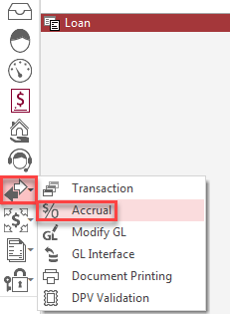
Enter in the date that you would like to accrue your loans through.
Always choose the day prior to today, then click on “Process”.

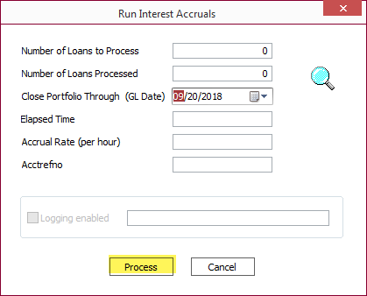

*** If you accrue through today then you will lock all records from allowing any updates.
When it is completed, click on “Done”:
