How to Manually Accrue Loans 4.x

Version 4.x
Go to Shortcut Bar, then select: Processing->Accrual
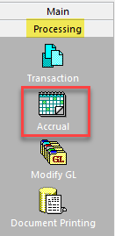
Always choose the day prior to today, then click on “Process”.

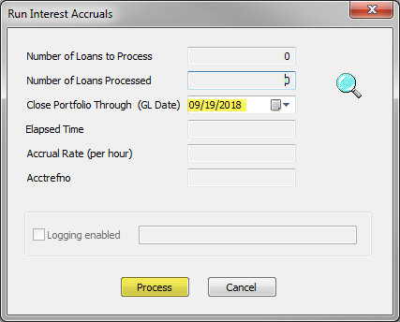

*** If you accrue through today then you will lock all records from allowing any updates.
When it is completed, click on “Done”:
